Experiment 1: Least Squares Line Fitting (y = a + bx)

Introduction
In this experiment, apply the least squares method to find the best-fit straight line of the form y = a + bx for a set of data points. This technique minimizes the sum of the squares of the vertical distances between the observed values and the values predicted by the model. Determine the best-fitting straight line for a given dataset using the method of least squares.

Methodology
• Gather data pairs (xi, yi) for i=1..N
• Compute sums: ∑x, ∑y, ∑x2, ∑xy.
• Use normal equations:
b = N ∑(xy)−∑x⋅∑y / N ∑(x^2) − ( ∑x )^2, a = ∑y – b ∑x N
The method minimizes the sum of the squares of the vertical distances (errors) of the points from the line and two normal equations based on partial derivatives of error function Q with respect to 'a' and 'b' and solve them.

3. Algorithm Steps
- Take user input for x and y values.
- Calculate required summations: Σx, Σy, Σxy, and Σx².
- Use the normal equations to find 'a' and 'b'.
- Print the equation: y = a + bx.

4. C++ Code
#include <iostream>
using namespace std;
int main() {
const int N = 5;
double x[N], y[N];
cout << "Enter " << N << " values for x:\n";
for (int i = 0; i < N; i++) {
cout << "x[" << i + 1 << "]: ";
cin >> x[i];
}
cout << "Enter " << N << " values for y:\n";
for (int i = 0; i < N; i++) {
cout << "y[" << i + 1 << "]: ";
cin >> y[i];
}
double sum_x = 0, sum_y = 0, sum_xy = 0, sum_x2 = 0;
for (int i = 0; i < N; i++) {
sum_x += x[i];
sum_y += y[i];
sum_xy += x[i] * y[i];
sum_x2 += x[i] * x[i];
}
double b = (N * sum_xy - sum_x * sum_y) / (N * sum_x2 - sum_x * sum_x);
double a = (sum_y - b * sum_x) / N;
cout << "\nLeast Squares Line Equation: y = " << a << " + " << b << "x" << endl;
return 0;
}

5. Input / Output
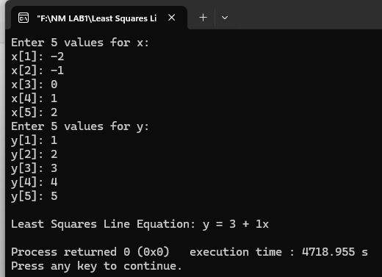

6. Conclusion
The method of least squares was successfully used to fit a straight line to the given data points.
Experiment 2: Least Squares Parabola Fitting (y = a + bx + cx²)

1. Introduction
In this experiment, use the least squares method to fit a parabola to a given dataset. When data shows curvature, modeling with a parabola using least squares produces a more accurate fit than a straight line.

2. Methodology
• Compute sums:
∑x, ∑x^2, ∑x^3, ∑x^4, ∑y,∑xy,∑x^2y
- Solve the 3x3 normal equations via determinants to find a, b, c.

3. Algorithm Steps
- Take user input for x and y values.
- Calculate summations: Σx, Σx², Σx³, Σx⁴, Σy, Σxy, Σx²y.
- Form and solve the normal equations using Cramer's Rule.
- Output the equation y = a + bx + cx².

4. C++ Code
#include <iostream>
using namespace std;
int main() {
const int N = 4;
double x[N], y[N];
cout << "Enter " << N << " values for x:\n";
for (int i = 0; i < N; i++) {
cin >> x[i];
cout << "Enter " << N << " values for y:\n";
for (int i = 0; i < N; i++) {
cin >> y[i];
double sum_x = 0, sum_x2 = 0, sum_x3 = 0, sum_x4 = 0;
double sum_y = 0, sum_xy = 0, sum_x2y = 0;
for (int i = 0; i < N; i++) {
double xi = x[i], yi = y[i];
sum_x += xi;
sum_x2 += xi * xi;
sum_x3 += xi * xi * xi;
sum_x4 += xi * xi * xi * xi;
sum_y += yi;
sum_xy += xi * yi;
sum_x2y += xi * xi * yi;
}
double D = N * (sum_x2 * sum_x4 - sum_x3 * sum_x3)
- sum_x * (sum_x * sum_x4 - sum_x2 * sum_x3)
+ sum_x2 * (sum_x * sum_x3 - sum_x2 * sum_x2);
double Da = sum_y * (sum_x2 * sum_x4 - sum_x3 * sum_x3)
- sum_x * (sum_xy * sum_x4 - sum_x2y * sum_x3)
+ sum_x2 * (sum_xy * sum_x3 - sum_x2 * sum_x2y);
double Db = N * (sum_xy * sum_x4 - sum_x2y * sum_x3)
- sum_y * (sum_x * sum_x4 - sum_x2 * sum_x3)
+ sum_x2 * (sum_x * sum_x2y - sum_xy * sum_x2);
double Dc = N * (sum_x2 * sum_x2y - sum_x3 * sum_xy)
- sum_x * (sum_x * sum_x2y - sum_xy * sum_x2)
+ sum_y * (sum_x * sum_x3 - sum_x2 * sum_x2);
double a = Da / D;
double b = Db / D;
double c = Dc / D;
cout << "\nLeast Squares Parabola: y = " << a << " + " << b << "x + " << c << "x^2" << endl;
return 0;
}

5. Input / Output

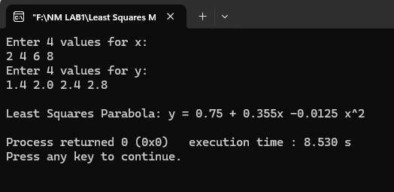

6. Conclusion
The least squares method was effectively applied to fit a second-degree polynomial (parabola) to the input dataset.

